**8D7N Jiuzhaigou-Maoxian-Chengdu No Shopping TOUR**

**Period : Oct, 2019- Mar 2020,**

**Pax : 15pax+1FOC**

**Hotel : 4**** or similar**

**Meal : Normal meals**

**DAY 01 : ARRIVAL CHENGDU (--/--/--)**

Pick up Airport,Transfer to Hotel for rest.

**DAY 02 : CHENGDU – JIUZHAIGOU (B, L,D) by coach 7H**

Breakfast at Hotel

Transfer to Jiuzhaigou

**Die Xi Hai Zi**

**Song Pan Ancient Town**

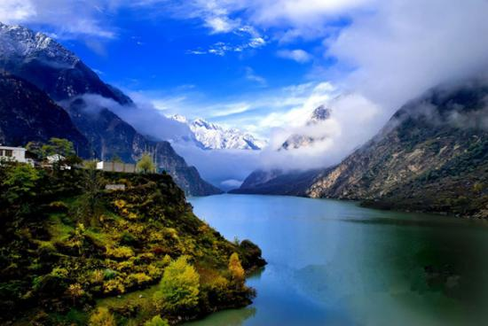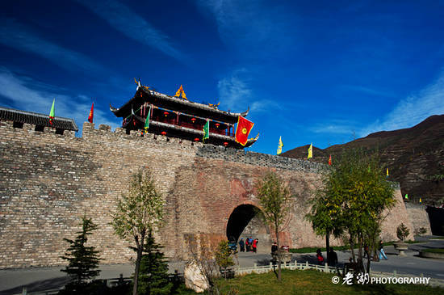

**DAY 03 : JIUZHAIGOU (B, LD)**

Breakfast at Hotel

**Jiuzhaigou Scenic Area**

Jiuzhaigou National Park（include public Vehicle)

Nuorilang Waterfall

Lying dragon Lake

Tiger Lake

Mirror Lake

Long Lake

Tibetan Show (Optional)

**DAY 04 : JIUZHAIGOU – HUANGLONG by coach 2.5H --MAOXIAN (B, L, D)**

Breakfast at Hotel

**Huanglong Scenic Area(EXCLUDE CABLE CAR )**

**DAY 05 : MAOXIAN – LESHAN – E’mei Mountain (B, L ,D)**

Breakfast at Hotel

**Baishi Qiang village**

Transfer to Leshan

**Grand Buddha (boat tour)**

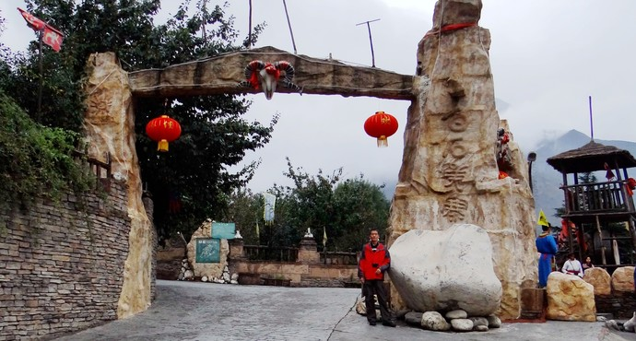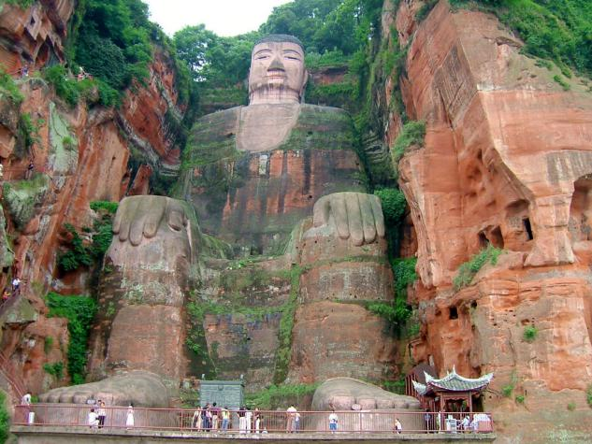

**DAY 06 : E’mei Mountain -- CHENGDU (B, L,D) by coach 4H**

Breakfast at Hotel

**Baoguo Temple**

**Fuhu Temple**

**Transfer to Chengdu.**

**Wide & Narrow Alley**

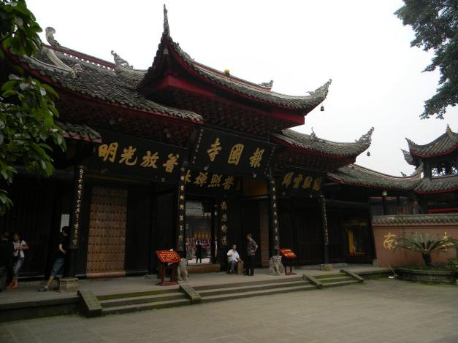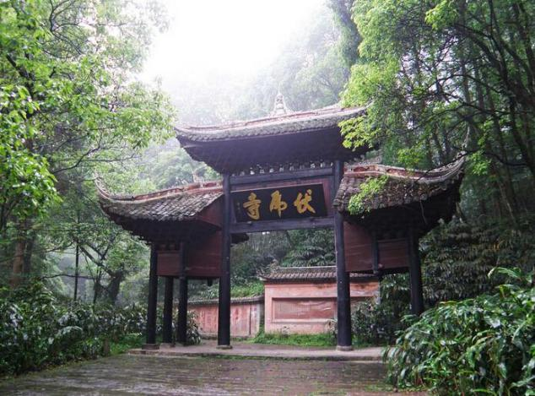

**DAY 07 : CHENGDU (B, L,D)**

Breakfast at Hotel

**Panda Breeding Camp(included Battery car)**

**Jinli Ancient Street**

**Chungxi Road & Tai Koo Li free shopping**

**DAY 08 : CHENGDU (B)**

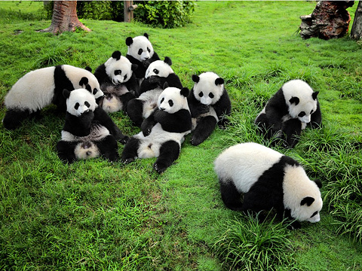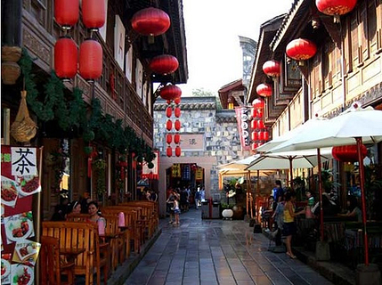

One way send to airport,Tour end.

**Hotel 4*/5*local or similar**

**Chengdu: Grand Kingtown Hotel or similar local 5**

[**https://hotels.ctrip.com/hotel/7861875.html?isFull=F**](https://hotels.ctrip.com/hotel/7861875.html?isFull=F)

**Jiuzhaigou:Soluxe Hotel Jiuzhaigou or similar local 4**

[**https://hotels.ctrip.com/hotel/471473.html**](https://hotels.ctrip.com/hotel/471473.html)

**Maoxian: Westqiang Homeland Hotel or similar local 4**

[**https://hotels.ctrip.com/hotel/2377395.html?CheckIn=2018-09-06&CheckOut=2018-09-07**](https://hotels.ctrip.com/hotel/2377395.html?CheckIn=2018-09-06&CheckOut=2018-09-07)

**E’mei mountain:Garden City E'mei Hotel & Resorts or similar local 4**

[**https://hotels.ctrip.com/hotel/1195421.html?CheckIn=2018-07-11&CheckOut=2018-07-12**](https://hotels.ctrip.com/hotel/1195421.html?CheckIn=2018-07-11&CheckOut=2018-07-12)

**Oct-15th Nov**

|  |  |  |  |  |
| --- | --- | --- | --- | --- |
| **PAX**  **(Adult)** | **4 STAR (per pax)** | | | |
| **TWN（USD）** | **SGL SUPL（USD）** | **CWB**  **(USD)** | **CNB**  **(USD)** |
| **15+1FOC** | **380/pax** | **80** | **350** | **290** |

**15th Nov-Mar,2020**

|  |  |  |  |  |
| --- | --- | --- | --- | --- |
| **PAX**  **(Adult)** | **4 STAR (per pax)** | | | |
| **TWN（USD）** | **SGL SUPL（USD）** | **CWB**  **(USD)** | **CNB**  **(USD)** |
| **15+1FOC** | **350/pax** | **80** | **315** | **270** |

**If Tour start after 15 Nov,can reduce $25/pax.**

**The above quotation included:**

-Accomodation as per mention

-English speaking guide

-Meals & Entrance fee

- 1 free bottle of water

**The above quotation excluded:**

**Tips for guide,driver (USD 4/pax/day )**

-China Visa

-Personal Expenses,TL Fee,Apt handing ,et**c**